GRADE: IV NAME:
DATE: SUB: SOCIAL
WORKSHEET- 9
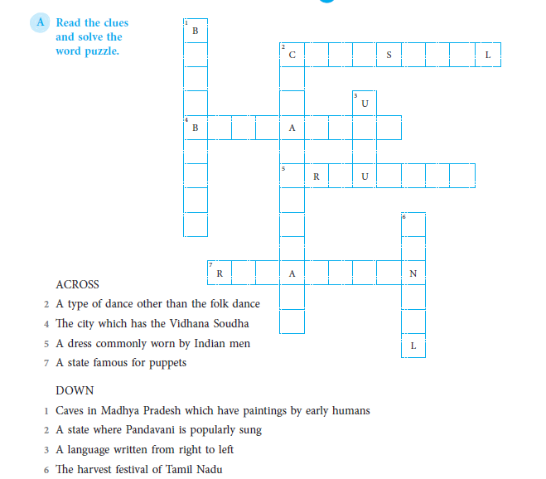
17. THE RICH CULTURE

